Unit 6: Selecting Productions on the Basis of Their
Utilities and Learning these Utilities

Occasionally, we have had cause to set parameters of productions so that one production will be preferred over another in the conflict resolution process. Now we will examine how production utilities are computed and used in conflict resolution. We will also look at how these utilities are learned.

6.1 The Theory

Each production has a utility associated with it which can be set directly as we have seen in some of the previous units. In this unit we will describe how those utilities can be learned from experience. Like activations, utilities have noise added to them. The noise is controlled by the utility noise parameter s which is set with the parameter :egs. The noise is distributed according to a logistic distribution with a mean of 0 and a variance of

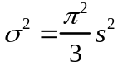

If there are a number of productions competing with expected utility values Uj the probability of choosing production i is described by the formula

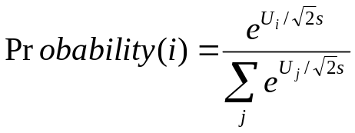

where the summation is over all the productions which are currently able to fire (their conditions were satisfied during the matching). Note however that that equation only serves to describe the production selection process. It is not actually computed by the system. The production with the highest utility (after noise is added) will be the one chosen to fire.

6.2 Building Sticks Example

We will illustrate these ideas with an example from problem solving. Lovett (1998) looked at participants solving the building-sticks problem illustrated in the figure below. This is an isomorph of Luchins waterjug problem that has a number of experimental advantages. Participants are given an unlimited supply of building sticks of three lengths and are told that their objective is to create a target stick of a particular length. There are two basic strategies they can select – they can either start with a stick smaller than the desired length and add sticks (like the addition strategy in Luchins waterjugs) or they can start with a stick that is too long and “saw off” lengths equal to various sticks until they reach the desired length (like the subtraction strategy). The first is called the undershoot strategy and the second is called the overshoot strategy. Subjects show a strong tendency to hillclimb and choose as their first stick a stick that will get them closest to the target stick.
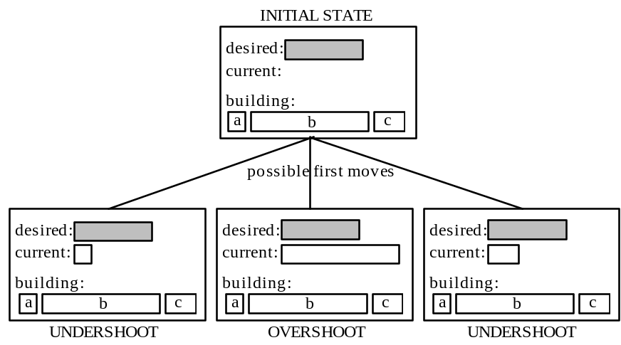

You can go through a version of this by loading the model bst-nolearn. By calling the command (do-set) you will run through a pair of problems in a version of the task built to run with a model (this is not the original experiment) and it will return a list of two items indicating which strategy, overshoot or undershoot, that you chose first. The experiment will look something like this:

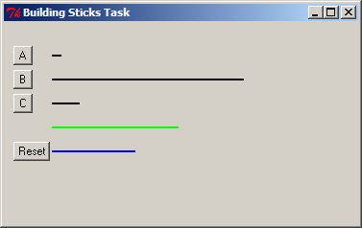

To do the task you will see four lines initially. The top three are black and correspond to the building sticks you have available. The fourth line is green and that is the target length you are attempting to build. The stick you have built will be blue and below the target stick. You will build the current stick by pressing the button to the left of a stick you would like to use next. If your current line is shorter than the target the new stick will be added to the current stick, and if your current line is longer than the target the new stick will be subtracted from the current stick. When you have successfully matched the target length the word “Done” will appear below the current stick and you will be able to progress to the next trial. At any time you can hit the button labeled Reset to clear the current stick and start over.

As it turns out, both of these problems can only be solved by the overshoot strategy. However, the first one looks like it can be solved more easily by the undershoot strategy. The exact lengths of the sticks in pixels are:

A = 15 B = 200 C = 41 Goal = 103

The difference between B and the goal is 97 pixels while the difference between C and the goal is only 62 pixels – a 35 pixel difference of differences. However, the only solution to the problem is B – 2C – A. The same solution holds for the second problem:

A = 10 B = 200 C = 29 Goal = 132

But in this case the difference between B and the goal is 68 pixels while the difference between C and the goal is 103 pixels – a 35 pixel difference of differences in the other direction. You can run the model on these problems and it will tend to choose undershoot for the first and overshoot for the second but not always. To run the model you will need to change the *actr-enabled-p* value to t and then reload. You can run it multiple times by calling the function collect-data with one argument which is the number of runs through the two trials. The following is the outcome of 100 trials (you may want to make the window virtual if you plan on running the model over lots of trials):

> (collect-data 100)
(25 73)

The two numbers in the list returned are the number of times overshoot was chosen on the first problem and the second problem respectively.

The model for the task involves a good number of productions for encoding the screen and selecting sticks. However, the behavior of the model is really controlled by four productions that make the decision as to whether to apply the overshoot or the undershoot strategy.

(p decide-over
=goal>
isa try-strategy
state choose-strategy
strategy nil
=imaginal>
isa encoding
under =under
over =over

!eval! (< =over (- =under 25))

==>
=imaginal>
=goal>
state prepare-mouse
strategy over
+visual-location>
isa visual-location
kind oval
screen-y 60)

(p force-over
=goal>
isa try-strategy
state choose-strategy
- strategy over
==>
=goal>
state prepare-mouse
strategy over
+visual-location>
isa visual-location
kind oval
screen-y 60)

(p decide-under
=goal>
isa try-strategy
state choose-strategy
strategy nil
=imaginal>
isa encoding
over =over
under =under

!eval! (< =under (- =over 25))
==>
=imaginal>
=goal>
state prepare-mouse
strategy under
+visual-location>
isa visual-location
kind oval
screen-y 85)

(p force-under
=goal>
isa try-strategy
state choose-strategy
- strategy under
==>
=goal>
state prepare-mouse
strategy under
+visual-location>
isa visual-location
kind oval
screen-y 85)

The key information is in the over and under slots of the chunk in the imaginal buffer. The over slot encodes the pixel difference between stick b and the target stick, and the under slot encodes the difference between the target stick and stick c. These values have been computed by prior productions that encode the problem. If one of these differences appears to get the model much closer to the target (more than 25 pixels closer than the other) then the decide-under or decide-over productions can fire to choose the strategy. In all situations, the other two productions, force-under and force-over, can apply. Thus, if there is a clear difference in how close the two sticks are to the target stick there will be three productions (one decide, two force) that can apply and if there is not then just the two force productions can apply. The choice among the productions is determined by their relative utilities which we can see using the Procedural Viewer in the environment, or by using the spp command:

> (spp force-over force-under decide-over decide-under)
Parameters for production FORCE-OVER:
:utility 8.720
:u 10.000
:at 0.050
Parameters for production FORCE-UNDER:
:utility 8.328
:u 10.000
:at 0.050
Parameters for production DECIDE-OVER:
:utility 16.871
:u 13.000
:at 0.050
Parameters for production DECIDE-UNDER:
:utility 6.597
:u 13.000
:at 0.050

The utility values, u, were set by the following spp command in the model:

(spp decide-over :u 13)
(spp decide-under :u 13)
(spp force-over :u 10)
(spp force-under :u 10)

The :u parameters for the force productions are set to 10 while they are set to a more optimistic 13 for the decide productions. The :utility parameter shows the last computed utility value for the production during a conflict-resolution event and includes the effect of utility noise. Thus, we see that even though the true utility for decide-over is 13 it had a utility of 16.871 the last time it was matched in conflict-resolution. Unless a production is explicitly assigned a value for u it is given a default of 0. Therefore, the above four productions are the only ones in the model with non-zero utilities.

Let us consider how these productions apply in the case of the two problems in the model. Since the difference between the under and over differences is 35 pixels, there will be one decide and two force productions that match for both problems. Let us consider the probability of choosing each production according to the equation.

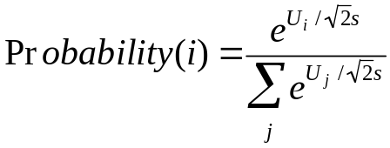

In the model, the parameter s is set at 3. First, consider the probability of the decide production:

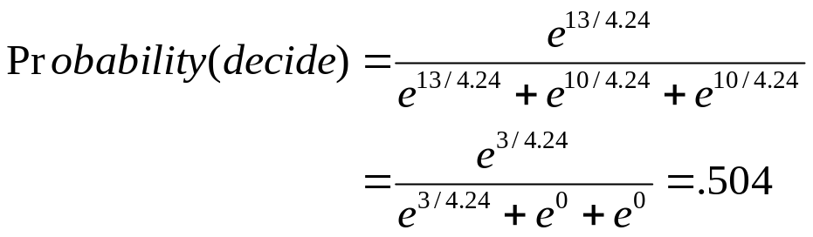

Similarly, the probability of the two force productions can be shown to be .248. Thus, there is a .248 probability that a force production will fire that has the model try to solve the problem in the direction other than it appears.

6.3 Utility Learning

So far we have only considered the situation where the production parameters are static. The utilities of productions can also be learned as the model runs based on rewards that are received by the model. When utility learning is enabled, they are updated according to a simple integrator model (e.g. see Bush & Mosteller, 1955).. If U_{i}(n-1) is the utility of a production i after its n-1st application and R_{i}(n) is the reward the production receives for its nth application, then its utility U_{i}(n) after its nth application will be

Difference Learning Equation

where α is the learning rate and is typically set at .2 (this can be changed by adjusting the :alpha parameter with the sgp command). This is also basically the Rescorla-Wagner learning rule (Rescorla & Wagner, 1972). According to this equation the utility of a production will be gradually adjusted until it matches the average reward that the production receives.

There are a couple of interesting issues about the reward itself. Rewards occur at various times not necessarily associated with any production -- for instance, in the case of a monkey it may press a button and receive a squirt of juice a second later. A number of productions may have fired before the reward is delivered. The reward R_{i}(n) that production i will receive will be the external reward received minus the time from production i’s selection to the reward. This serves to give less reward to more distant productions. This is like the temporal discounting in reinforcement learning but proves to be more robust within the ACT-R architecture (not suggesting it is generally more robust). This reinforcement goes back to all the productions which have fired between the current reward and the previous reward.

While it is possible to introduce rewards into the system at any time by calling the trigger-reward command, one can also attach them to specific productions, and this is often an efficient way to introduce rewards. For instance, in the building sticks task there is one production that fires when an action has been successful and another which fires when it has not:

(p read-done
=goal>
isa try-strategy
state read-done
=visual>
isa text
value "done"
==>
+goal>
isa try-strategy
state start)

(p pick-another-strategy
=goal>
isa try-strategy
state wait-for-click
?manual>
state free
=visual-location>
isa visual-location
> screen-y 100
==>
=goal>
state choose-strategy)

One can associate rewards with these outcomes by setting the reward value of a production:

(spp read-done :reward 20)
(spp pick-another-strategy :reward 0)

When read-done fires it will propagate a reward of 20 back to the previous productions which have been fired. Of course, productions earlier in the chain will receive smaller values because the time to the reward is subtracted from the reward. If pick-another-strategy fires, a reward of 0 will be propagated back – which means that previous productions will actually receive a negative reward because of the time that passed. Consider what happens when a sequence of productions leads to a dead end, pick-another-strategy fires, another sequence of productions fire that leads to a solution, and then read-done fires. The reward associated with read-done will propagate back only to the production which fired after pick-another-strategy and no further because the reward only goes back as far as the last reward. Note that the production read-done will receive its own reward, but pick-another-strategy will not receive any of read-done’s reward since it will have received the reward from its own firing.

6.4. Learning in the Building Sticks Task

The following are the percent choice of overshoot for each of the problems in the training set from an experiment with a building sticks task reported in Lovett & Anderson (1996):

Lovett, M. C., & Anderson, J. R. (1996). History of success and current context in problem solving: Combined influences on operator selection. Cognitive Psychology, 31, 168-217.

a b c Goal %OVERSHOOT
15 250 55 125 20
10 155 22 101 67
14 200 37 112 20
22 200 32 114 47
10 243 37 159 87
22 175 40 73 20
15 250 49 137 80
10 179 32 105 93
20 213 42 104 83
14 237 51 116 13
12 149 30 72 29
14 237 51 121 27
22 200 32 114 80
14 200 37 112 73
15 250 55 125 53

The majority of these problems look like they can be solved by undershoot and in some cases the pixel difference is greater than 25. However, the majority of the problems can only be solved by overshoot. The first and last problems are interesting because they are identical and look strongly like they are undershoot problems. It is the only problem that can be solved either by overshoot or undershoot. Only 20% of the participants solve the first problem by overshoot but after the sequence of problems this rises to 53% for the last problem.

The model bst-learn is the one that simulates this experiment. This is the same as the model in bst-nolearn except that the learning mechanism is enabled (the :ul parameter is t in the sgp command) and all of the stimuli of the experiment are presented by do-set. The productions are given the same initial values as in bst-nolearn. The values at the start of the experiment look like this:

> (spp force-over force-under decide-over decide-under)
Parameters for production FORCE-OVER:
:utility NIL
:u 10.000
:at 0.050
:reward NIL
Parameters for production FORCE-UNDER:
:utility NIL
:u 10.000
:at 0.050
:reward NIL
Parameters for production DECIDE-OVER:
:utility NIL
:u 13.000
:at 0.050
:reward NIL
Parameters for production DECIDE-UNDER:
:utility NIL
:u 13.000
:at 0.050
:reward NIL

The following is the performance of the model on a 100 simulation run:

> (collect-data 100)
CORRELATION: 0.803
MEAN DEVIATION: 17.129

Trial 1 2 3 4 5 6 7 8 9 10 11 12 13 14 15
23.0 60.0 59.0 70.0 91.0 42.0 80.0 86.0 59.0 34.0 33.0 22.0 54.0 72.0 56.0

DECIDE-OVER : 13.1506
DECIDE-UNDER: 11.1510
FORCE-OVER : 12.1525
FORCE-UNDER : 6.5943

Also printed out are the average values of the utility parameters for the critical productions after each run through the experiment over these 100 runs. As can be seen, the two over productions have increased their utility while the under productions have had a drop off. On average, the force-over production has a slightly higher value than the decide-under production. It is this change in values that creates the increased tendency to choose the overshoot strategy.

6.5 Learning in a Probability Choice Experiment

Your assignment is to develop a model for a "probability matching" experiment run by Friedman et al (1964). The difference between this assignment and earlier ones is that you are responsible for almost all of the code for the model, including the code which presents the experiment. The experiment to be implemented is very simple. The basic procedure, which is repeated for 48 trials, is:

1. The participant is presented with a screen saying "Choose"
2. The participant either types H for heads or T for tails
3. The screen is cleared and presents as feedback the correct answer, either "Heads" or "Tails" for 1 second.

Friedman et al arranged it so that heads was the correct choice on 10%, 20%, 30%, 40%, 50%, 60%, 70%, 80%, and 90% of the trials (independent of what the participant had done). For your experiment you will only be concerned with the 90% condition. Thus, your experiment will be 48 trials and “Heads” will be the correct answer 90% of the time. We have averaged together the data from the 10% and 90% conditions (flipping responses) to get an average proportion of choice of the dominant answer in each block of 12 trials. These proportions are 0.66, 0.78, 0.82, and 0.84. This is the data that your model is to fit. Note, this is not the percentage of correct responses – the correctness of the response does not matter. Your model must begin with a 50% chance of saying heads, then rapidly adjust its probabilities so that it averages close to 66% over the first block of 12 trials, and increase to about 84% by the final block. You will run the model through the experiment many times (resetting before each experiment) and average the data of those runs for comparison. As an aspiration level, this is the performance of the model that I wrote, averaged over 100 runs:

> (collect-data 100)
CORRELATION: 0.991
MEAN DEVIATION: 0.012
Original Current
0.660 0.663
0.780 0.787
0.820 0.816
0.840 0.818

In achieving this, the parameters I worked with were the noise in the utilities (set by the :egs parameter in the sgp command) and the rewards associated with successful and unsuccessful predictions.

The starting model you are given for this task, choice, contains only the functions necessary to run a person through one trial and to collect a key press response using the “trial at a time” experiment writing style as discussed in the unit 4 experiment code document. When either a person or the model presses a key, the string representing that key will be saved in the global variable *response*. The function do-trial-person will run one trial returning the key that was pressed. You will have to write a similar function to run the model through one trial, which should be named do-trial-model. You also need to write a function called collect-data that takes one parameter and runs the experiment that many times and prints out the average results of the runs and the correlation and deviation of the average data to the experimental data. You also must write the model for the task that fits the data.

My suggestion would be to first write the do-trial-model function and a model that does the task (without trying to fit the data), and make sure that works correctly. Next write a function to run a block of 12 trials and test that to make sure the model works correctly between trials. Then write a function to iterate over 4 blocks for running one pass of the experiment and test that. After that is working write the collect-data function to run the experiment multiple times. Only then should you be concerned with actually fitting the model to the data, once you are sure everything else works.

To write the experiment for the model to interact with you will need to use a few ACT-R functions that were discussed in the experiment description files. Those functions will be described again here, and the models should provide plenty of examples of their use.

The reset function initializes ACT-R. It returns the model to the initial state as specified in the model file. It is the programmatic equivalent of pressing the “Reset” button in the environment.

The function install-device takes one parameter which should be a window. That parameter tells ACT-R with which window the model will be interacting. Everything in that window can be seen by the model, and all of the model’s motor actions (key presses and mouse clicks) will affect that window.

The proc-display function is called to make the model “look” at the window. The model only encodes the screen when requested with a call to proc-display. Thus, for the model to notice a change to the window proc-display must be called after the change has occurred. This function performs the buffer stuffing of the visual-location buffer if it is empty and triggers the re-encoding if the model is attending an item.

The run function can be used to run the model until it has nothing to do or a particular amount of time has passed. It has one required parameter, the maximum amount of time to run the model.

The run-full-time function can be used to run the model for a specific amount of time. It takes one parameter which is the amount of time to run the model.

In addition to these functions there are the correlation and mean-deviation functions that you will need to use. These calculate the correlation and mean-deviation between two lists of numbers.

Here is the function that runs the model through the paired associate task from unit 4:

(defun do-experiment-model (size trials)
(let ((result nil)
(window (open-exp-window "Paired-Associate Experiment" :visible nil)))

(reset)

(install-device window)

(dotimes (i trials)
(let ((score 0.0)
(time 0.0)
(start-time))
(dolist (x (permute-list (subseq *pairs* (- 20 size))))

(clear-exp-window)
(add-text-to-exp-window :text (car x) :x 150 :y 150)

(setf *response* nil)
(setf *response-time* nil)
(setf start-time (get-time))

(proc-display)
(run-full-time 5)

(when (equal (second x) *response*)
(incf score 1.0)
(incf time (- *response-time* start-time)))

(clear-exp-window)
(add-text-to-exp-window :text (second x) :x 150 :y 150)

(proc-display)
(run-full-time 5))

(push (list (/ score size) (and (> score 0) (/ time (* score 1000.0)))) result)))

(reverse result)))

It is more complicated than the function you will need for this assignment because it is recording response times and averaging the data over multiple runs which your do-trial-model function will not be doing. It also calls reset which you should not do in your do-trial-model function because you want the model to continue to learn from trial to trial. You should only call reset at the start of each pass through the whole experiment. Ignoring those complications, it performs a similar sequence of operations to those necessary to do this experiment: opening a window, presenting an item of text, running the model, clearing the screen, displaying another item of text and then running the model again (the code highlighted in red). Note however that the timing for the choice task is not the same as the timing of the paired associate experiment.

In the choice file provided the do-trial-person function provides the structure for the displaying of the items in the choice task:

(defun do-trial-person ()
(let ((window (open-exp-window "Choice Experiment" :visible t)))

(add-text-to-exp-window :text "choose" :x 50 :y 100)

(setf *response* nil)

(while (null *response*)
(allow-event-manager window))

(clear-exp-window)

(add-text-to-exp-window :text (if (< (random 1.0) .9) "heads" "tails")
:x 50 :y 100)

(sleep 1.0)
*response*))

What you must do is write the do-trial-model function that presents the display as do-trial-person does, but has the appropriate interaction with ACT-R (the code colored green is not the interaction necessary for ACT-R to do the task and should not appear in your do-trial-model function).

It is also possible to write the experiment using an event-based style as discussed in the unit 4 experiment code document. That will require a little more work to program because it does not analogize as neatly to an existing model. If you would like to write the experiment in that way you should look at the Zbrodoff model as an example instead of the paired model as described above. In fact, the different ways to write the experiment can actually have an effect on the data fitting for this model because they will likely have slightly different timing on the events which will affect the rewards received by the productions. For the paired associate task the style of the experiment was not an issue because the lengths of the trials were fixed. In this case, because the trials transition on the response of the model, the event-based experiment will provide a more veridical timing sequence because the events of the experiment will not be impacted by components of the model other than its response. However, either solution is acceptable for the assignment.

